
ANNUAL AWARDS PRESENTATION

Our Annual presentation of awards ceremony was held last night and it was fantastic to see so many community members coming along to help us celebrate student achievement for this year. The weather was beautiful - a nice contrast to recent years and although we held our presentation ceremony indoors everyone was able to adjourn to the amphitheatre for the carol singing and visit from Santa.

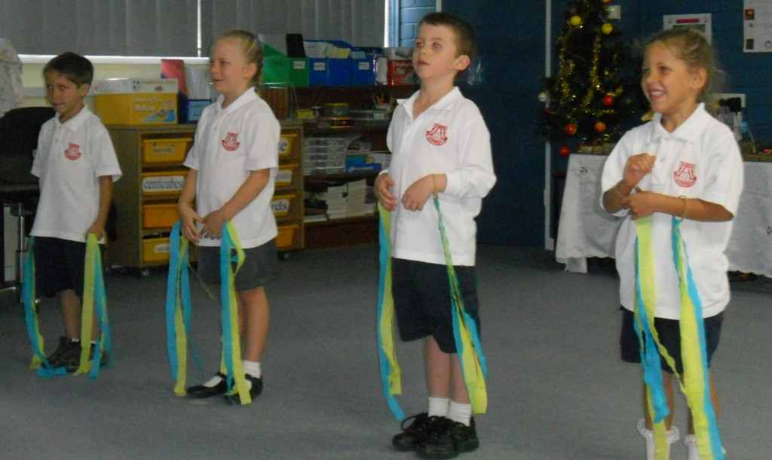
This year we were delighted to welcome many special guests to our ceremony including, Mr Darryl Ryan: Relieving School Education Director, Mrs Shirlee Straatsma: Community Librarian, Mrs Melinda Deas: Snowy Hydro, Mr Bruce Brian: Tumut Lions Club, Mr Bruce Pullen: Talbingo Progress Association, Mrs Jan Howard representing the family of the Late Mr Jack Bridle and teachers Mrs Tracey Pullen and Mrs Marika Stacy. Thank you to all our guests and to the organisations that have provided such wonderful support for our students and school for this ceremony and throughout the year.

MC’s Cassie and Molly did a great job with Aisha assisting with the award announcements.
Kindergarten Survival: Hugh, Quaid, Trinity and Jade
Encouragement: Cassie and Madison
Miles Franklin Award for Writing: Molly Polmeer
Jack Bridle Award for Citizenship: Phoenix
Snowy Hydro Award for Leadership: Aisha
Academic Excellence Award: Danielle
Principal’s Award: Trish

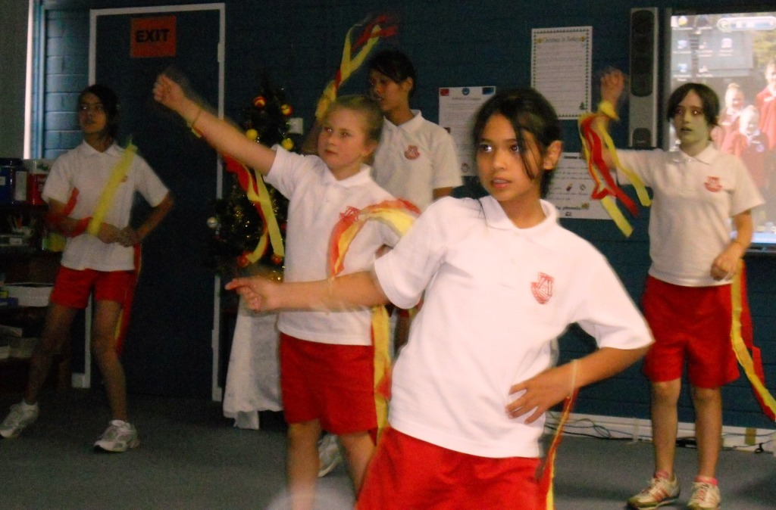
The audience was treated to three different performances during the evening which featured “Fireworks”, a favourite dance number the students have learned using their Wii Dance program. The show opener featured all the students singing “Boa Constrictor”, complete with actions, to the delight of the audience, many of whom probably remember the song from their school days. Kindergarten performed “Shake Yourself” enthusiastically shaking the night away.

With the formalities over for another year, it was time to relax and gather together in the amphitheatre for some carol singing and Santa’s visit.

Thank you once again to all parents, community members and organisations for your wonderful support throughout 2011. I wish you all a Merry Christmas and a happy holiday and look forward to a great year in 2012.
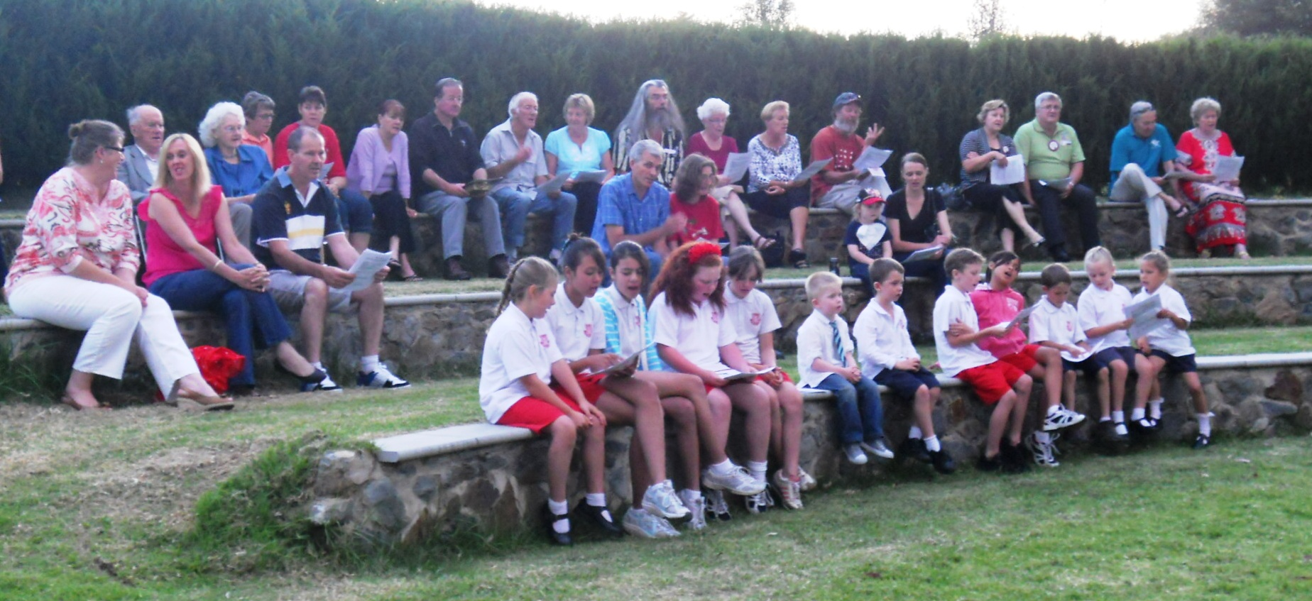

DIARY DATES

Term 1, 2012
Week 1 – Beginning Monday, 23rd January
Friday | Staff return to school
Week 2 – Beginning Monday, 30th January
Monday | All students return to school
Tuesday | Intensive Swimming commences

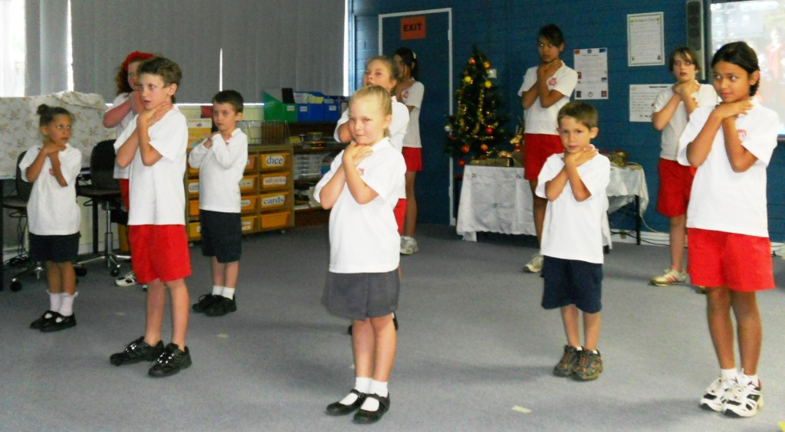

P&C Christmas raffle

The P&C Christmas Raffle was drawn following the presentation of awards. The lucky winners were: Sandra Pianelli, Marie Fillery, Mandy Dunn and Patty Dean.

The P&C raised $384 in total and would like to thank all who donated goods or bought tickets to support our children.

